Voucher Hunt
Customer Guide — how to use the app
This guide takes you from installing the app to using a voucher at the counter and spending the points you earn. Nothing technical, and about ten minutes to read.

What this app is
Voucher Hunt is a game that ends in a real discount. You pick a shop or restaurant running a campaign, spin a roulette to reveal the voucher you have won, then book the date and time you will come in and use it. You show a QR code at the counter and the discount is yours. Alongside the hunt you collect Loyalty Points — LP — every day and on everything you buy, and you spend those points on rewards from any partner in the network.
One thing to know up front. Everything happens in the Android app. There is no customer website to sign in to.

What you need before you start
- An Android phone with the Voucher Hunt app installed.
- A Philippine mobile number that can receive SMS. This is how you sign in, and how your booking confirmation arrives.
- That is all. There is no password to create and no account form to fill in.

Part 1 — Signing in
You sign in once, and it covers the whole app — not once per campaign.

Step 1 — Enter your mobile number
Open the app and type your mobile number in the format 09XX XXX XXXX, then tap Send code.
- Open the app.
- Tap the Mobile number field and type your number, for example 09171234567.
- Tap Send code.
You will know it worked: the screen changes to ask for a verification code.
[ Screenshot: Signing in with your mobile number — docs/images/customer-00-signin.png ]

Step 2 — Type the six-digit code
We text you a six-digit code. Type it into the Verification code field and tap Verify and continue. Delivery can take up to a minute, so give it a moment before assuming it has failed.
- Nothing arrived? Wait for the countdown on Resend code to finish, then tap it. You can also tap Change number if you mistyped.
- Take care typing it. After five wrong guesses the code stops working and you will need a new one.
- Codes do not last forever. If you leave the screen and come back much later, ask for a fresh code.
You will know it worked: you land on the Home tab and can start hunting.

Part 2 — The five tabs
The bar along the bottom of the screen never changes. Here is what each tab is for, so the rest of this guide has somewhere to point.
Tab | What it holds
Home | Every live campaign. Search or filter, then pick one to hunt.
Quests | Today's missions, your level, and the badges you have earned.
Vouchers | The vouchers you have won, and the QR code you show at the counter.
LP Shop | Spend your Loyalty Points on rewards from partner businesses.
More | Your Loyalty Points balance and wallet QR, your language, and your account.

Part 3 — Hunting a voucher
This is the main thing the app does. Seven screens, start to finish.

Step 1 — Pick a campaign
The Home tab lists every campaign running now. Each card shows the business, the offer and the dates. Use the search box to look for a campaign, business or location, or use the filter row to narrow by category — Restaurant, Online Shop, Beauty, Pet, Retail, Other. Tap Hunt now on the one you want.
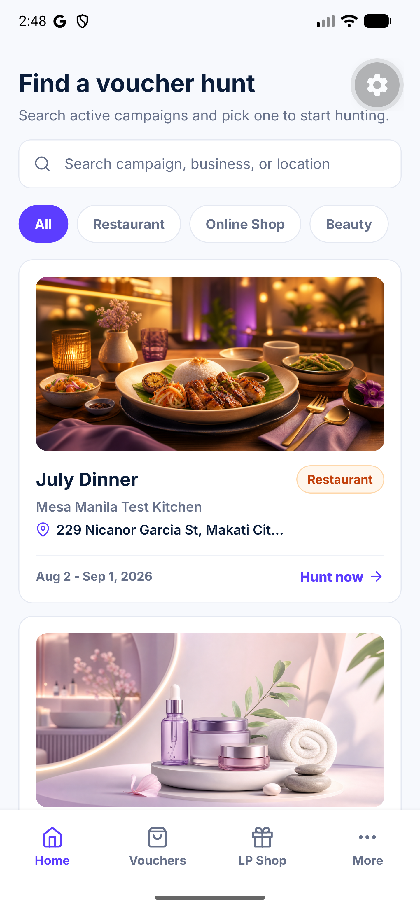
The Home tab, showing live campaigns

Step 2 — Start the hunt
The campaign page shows the offer and the rules. Read the two lines under the heading — they tell you that one spin reveals one voucher, and that higher discounts unlock fewer time slots. When you are ready, tap Let's Hunt!
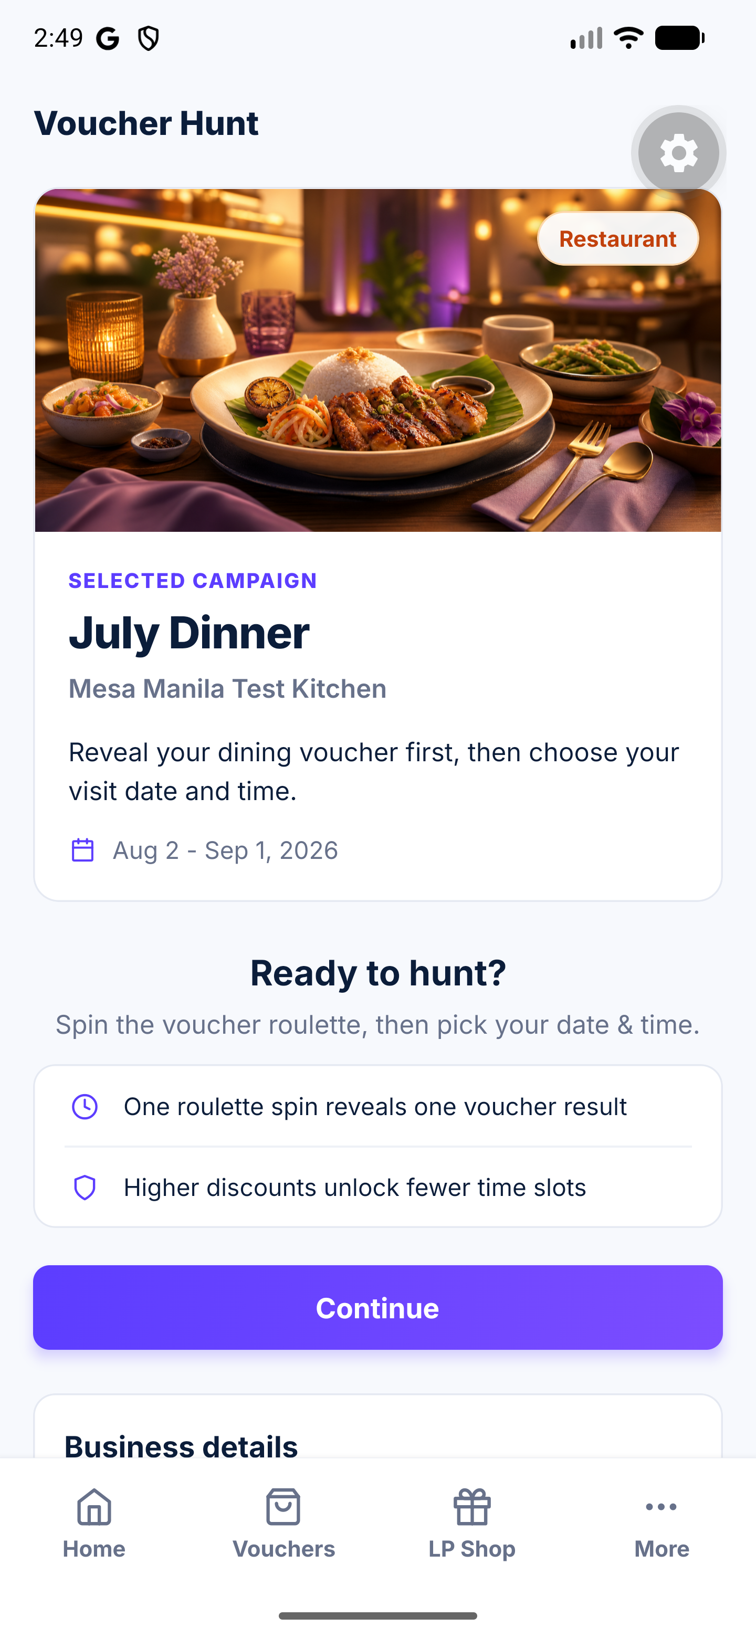
A campaign page, ready to start

Step 3 — Spin the roulette
Every voucher in the campaign passes by on the reel. Tap Stop the reel whenever you feel lucky — the reel slows down and lands on your prize. Where it lands is decided fairly by the app, not by how fast you tap.
You will know it worked: the screen says Voucher unlocked! and names what you won.
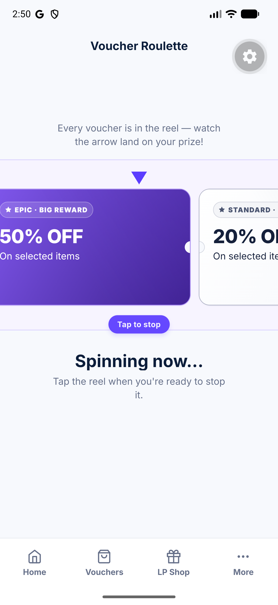
The reel mid-spin

Step 4 — Look at what you won
The results screen shows your voucher and what it is worth. Every voucher carries a rarity — Standard, Rare, Epic or Legendary — which is simply how hard it was to win. If you have an extra spin, you can use it here and choose between the results. When you are happy, tap Pick date & time.

Step 5 — Choose your date and time
Pick the day you will visit, then the time. Each time slot holds a set number of people; a slot that is full shows as Sold out, and one filling up warns you how many spots are left. Tap Continue.
Why some times are missing. You will only be shown the times your particular voucher is valid at. A bigger discount is usually offered at fewer times — often the quieter ones. This is not a fault; it is how the businesses keep a deep discount affordable.
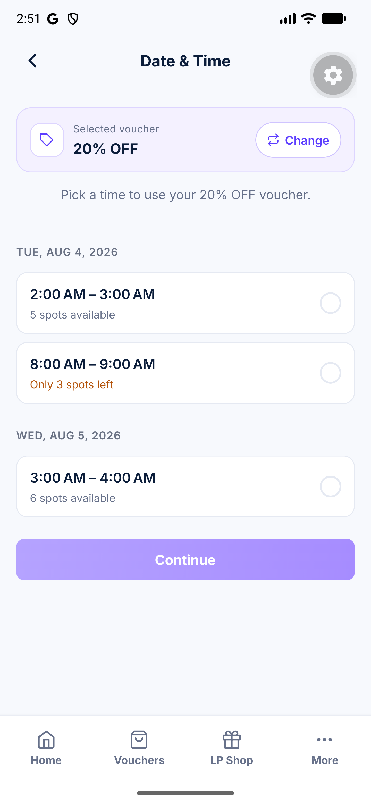
Choosing a date and time slot

Step 6 — Confirm your details
Enter the name the booking should be under, and the number of guests. Email is optional. Tap Confirm & Reserve.

Step 7 — Keep your voucher
You are done. The confirmation screen shows your voucher code and a QR code, and a confirmation SMS arrives with the discount, the date and the time. The voucher is also waiting for you in the Vouchers tab — you do not need to screenshot anything.
You will know it worked: the screen says You're all set! and shows a QR code.
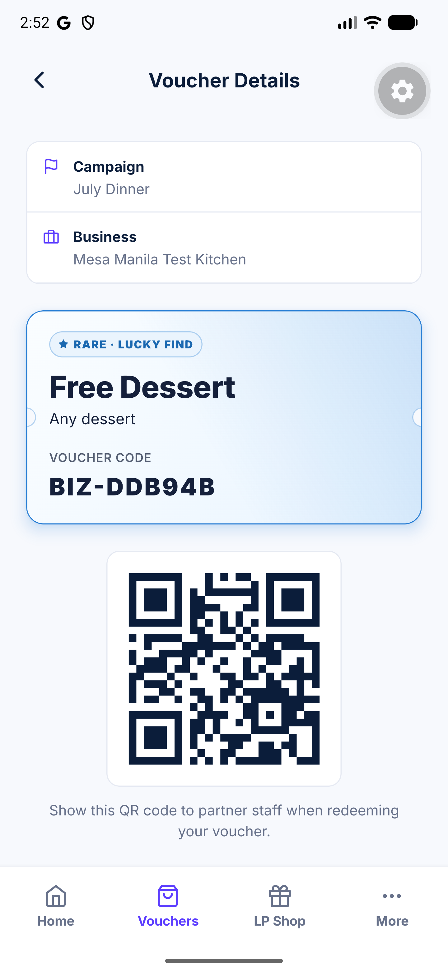
The issued voucher, with its QR code

Three rules worth knowing
- Your prize is drawn before you book. The app decides what you won first, then offers you the times that prize is available at. This is why the date picker sometimes looks emptier than the campaign page suggested.
- A hunt is resumed, never restarted. If you close the app halfway through, reopening the campaign puts you back where you left off. An interrupted spin shows you the result you already earned rather than charging you another spin.
- One voucher per campaign, per number. Once you have confirmed a voucher for a campaign, that is your voucher for it. You can still hunt every other campaign.

Part 4 — Using your voucher in store
- Arrive within the time slot you booked.
- Open the Vouchers tab and tap your voucher.
- Tap Show QR code and hold the screen up for the staff to scan.
- They confirm it on their screen, and the discount is applied to your bill as normal.
How long it lasts. Your voucher stays valid until the end of the slot you booked. There is no separate countdown from when you won it — the booking is the deadline.
Voucher status | What it means
Active | Won, booked, and not yet used. This is the one to show.
Redeemed | Already used at the counter. It cannot be used again.
Expired | The booked slot has passed without the voucher being used.
If you cannot make it. If something comes up, ask the staff whether the campaign allows rescheduling — some do, and they can move your booking to another slot from their side. If you simply do not turn up, staff can mark the booking as a no-show.

Part 5 — Loyalty Points
Loyalty Points, or LP, are the app's second half. They work across every partner in the network, not just the shop you earned them at. Your balance, your daily earnings and your wallet QR all live in the More tab.
[ Screenshot: The More tab, with your Loyalty Points and wallet QR — docs/images/customer-06-more.png ]

Four ways to earn
What you do | What you get
Open the app | A random 1–10 LP, once a day.
Refer a friend | 10 LP when one new person opens your link, once a day.
Pay at a partner | 5% of what you spent. A ₱500 purchase earns you 25 LP.
Finish missions | Some missions pay LP. See Part 6.
Used every day, the daily rewards alone add up to as much as 600 LP over a month.

Earning 5% at the counter
- Pay for your purchase as normal.
- Open the More tab and show the staff the wallet QR code on that screen.
- They scan it and enter what you paid.
You will know it worked: the new points appear on your balance in the More tab.

Spending your points
Open the LP Shop tab. You will find two kinds of reward:
- Partner items. Pick a partner, pick an item, and buy it with points. It is kept under My items with a QR code you show at that partner's counter to collect it.
- Global LP rewards. A voucher you can use at any partner, redeemed from your Global LP balance. You need at least 50 LP to make one, and it is good for a year.
Two pockets. Points you earn at a particular partner are held with that partner and shown separately in the shop. You can move them into your Global LP balance when you want to spend them somewhere else.
Part of a bill is fine. You do not have to spend the whole thing at once — an LP voucher can be used against part of a bill, and what is left stays on it.
[ Screenshot: The LP Shop, listing partner rewards — docs/images/customer-08-shop.png ]

Part 6 — Quests, levels and badges
The Quests tab is the part of the app worth opening daily.

Missions
Missions are small tasks that pay a reward — points, experience, or an extra hunt. There are two kinds, on two tabs:
- Daily. A fresh set every day. The screen tells you what time today's missions reset.
- Urgent. Run by a partner, near you, for a limited time and a limited number of people. These show how long is left and how many places remain.
Tap a mission to see what finishing it takes. When you have done it, tap Claim. Some urgent missions ask you to tap Join first, to hold your place, and some ask for evidence — usually a photo of your receipt. Someone at the partner checks that before the reward is paid, so those sit at Waiting for review for a while.
[ Screenshot: The Quests tab, showing today's missions — docs/images/customer-07-quests.png ]

Levels and XP
Experience — XP — decides your level, and there are five levels. Levels unlock things: bonus hunts each day, a head start on selected offers, and some partner offers that are open only from a certain level.
The one rule to remember. XP is not LP, and the difference matters. LP is a balance you spend. XP only ever counts up, and cannot be spent, transferred, refunded or withdrawn. You turn LP into XP on the Level up screen — that spends the points and cannot be undone — but spending LP never costs you a level, because your level is worked out from all the XP you have ever earned.

Achievements
Badges you keep for good. Each badge has tiers — Bronze, Silver, Gold and Royal — and each tier unlocks on its own as you go. They are grouped by what earns them: Hunt, Visit, Mission, Streak, Review, Referral, Explore and Points. You can pin your favourites as featured badges.

Part 7 — Referrals
Sharing the app earns you two separate things.
- Open the More tab and find the daily referral row.
- Tap Share and send the link however you like.
- When one new person opens it, you earn 10 LP — once a day.
Extra spins. Separately, sharing your link during a hunt earns you an extra roulette spin when a friend opens it. The results screen shows how many extra spins you have earned today and the daily cap.

Part 8 — Your account
All of this is in the More tab.
Setting | What it does
Your number | Shown at the top, as Signed in as.
Language | English, Korean, Chinese and Japanese.
About Voucher Hunt | Opens the product page in your browser.
Sign out | Ends the session on this phone. Your vouchers and points are safe and come back when you sign in again.
Delete my account | Opens the account deletion page. This is permanent.

If something goes wrong
Problem | What to do
No code arrived | Wait a full minute — delivery is not instant. Then use Resend code once the countdown ends. Check the number shown on screen is really yours; tap Change number if not.
The code is not accepted | After five wrong tries a code is dead. Ask for a new one with Resend code and type it carefully.
Every time slot says Sold out | Those are the slots for the prize you won, and they have filled up. Try another date, or another campaign.
No time slots at all | The times for that prize are gone or not open yet. The campaign page is the place to check back.
The app says a hunt is already in progress | You have a hunt part-finished on this number. Open the campaign again and it will put you back where you stopped.
Staff say the voucher is invalid | Check you are inside the slot you booked and that the voucher still shows as Active. A Redeemed voucher has already been used.
My points did not go up after a purchase | The 5% is added when staff scan your wallet QR from the More tab and enter the amount. If that was missed, ask at the counter.
I cannot make a Global LP voucher | You need at least 50 LP in your Global LP balance. Points held at a partner have to be moved to Global first.

Words used in this guide
Term | What it means
Campaign | One business's offer, running between two dates, that you can hunt.
Hunt | One run through a campaign: spin, win, book, confirm.
Slot | A specific date and time window you book, with a limited number of places.
Rarity | How hard a voucher was to win: Standard, Rare, Epic or Legendary.
LP (Loyalty Points) | The balance you earn and spend across every partner.
Global LP | The part of your balance that can be spent at any partner.
XP (experience) | What decides your level. It counts up and can never be spent.
Mission | A small task in the Quests tab that pays a reward.
Wallet QR | The code in your More tab that staff scan to give you the 5%.

